## File System

### Show File System Contents

The Show File System Contents displays the current available files in the file system. On clicking the Show File System Contents, a new window opens displaying the files present. The file path, name and size are displayed.

In case there are no files previously mounted on Talaria TWO, a new window opens displaying: No files mounted, please write some files using Write Files button.

Refer section: Write Files for writing files to Talaria TWO.

Figure 17: Show File System Contents

#### Read Files

To save files to a directory, click on folder icon before Read Files button. This opens a new window where the appropriate folder can be selected. Once the path to read files is selected, click on Read Files.

Figure 18: Select path to Read Files

Before using the Write Files, user can read the file system with Read Files to retain a copy of the Talaria TWO file system contents.

Figure 19: Read Files

#### Write Files

To write files, click on the folder icon before Write Files button and select the folder from the where the files can be written. Click on Write Files. Once done, the file system contents can be confirmed by clicking on Show File System Contents, where the said files will be displayed.

To write files into Talaria TWO, user must create a folder with the name data and place all certificates either directly into data or they can create multiple subfolders (for example: *freertos_sdk_x.y/examples/mqtt/certs/data*) and place the certificates inside the sub-directory and update the path as per the file system in the .c file.

Any number of files/folders inside data will be written.

On clicking the Folder icon before Write Files button option, a window to browse the files opens. Select the folder where the appropriate files/certificates are present and click on Select Folder. Though the GUI window does not display the files present in the selected folder, all the files present in selected folder will be written to Talaria TWO.

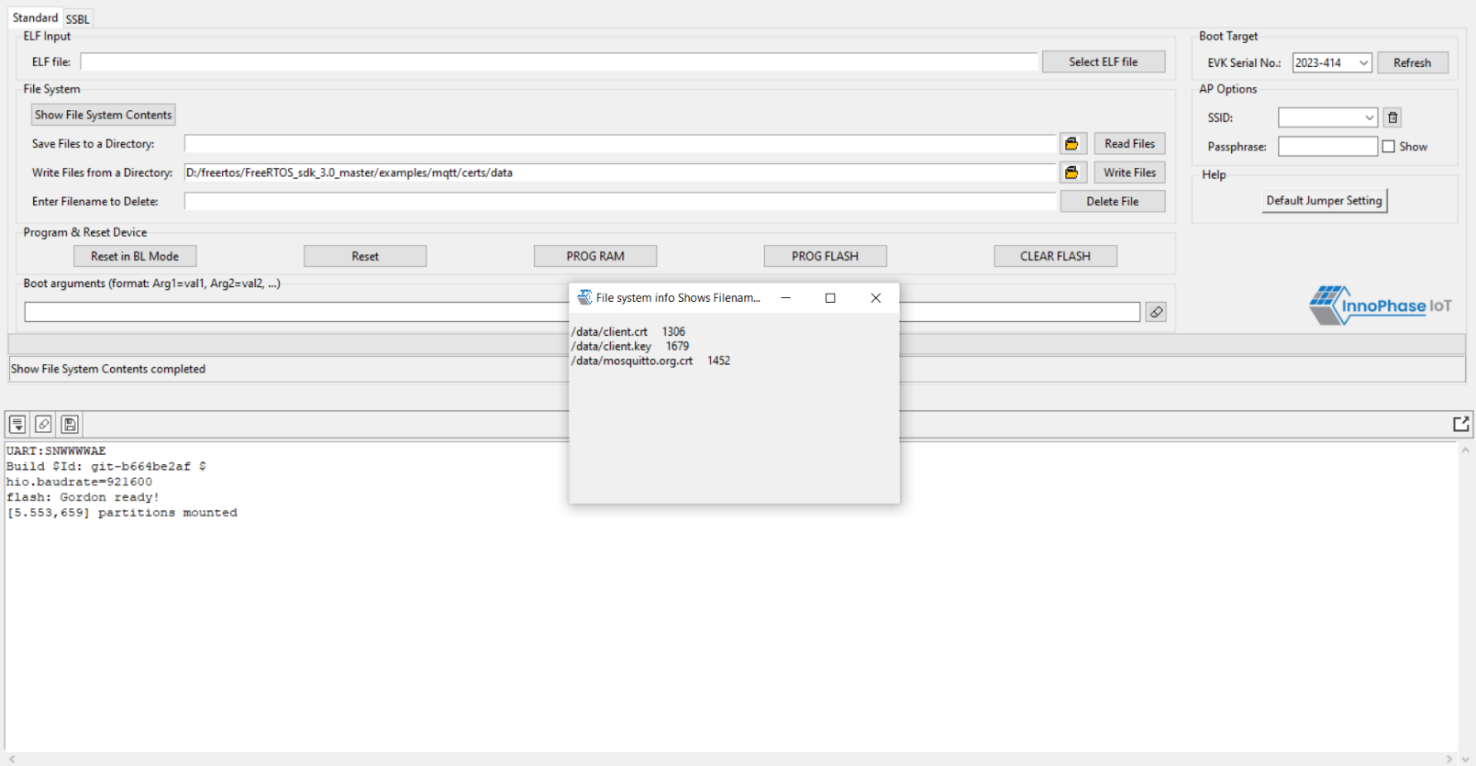

Figure 20: Write Files

**Note**:

1. The maximum size limit of the directory selected using Write Files is equal to the size of DATA partition (in EVB partition table).

If the default partition table is used, the maximum limit is 120 Kbytes.

1. In case the user needs the existing files, the user will have to Read Files to retrieve the existing files before initiating Write Files. On taking a back-up, click Yes as shown in Figure 21.

 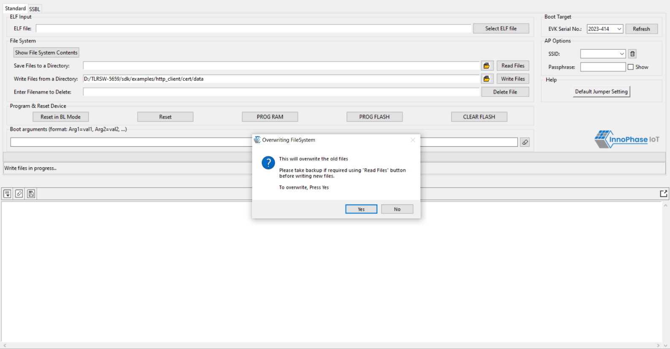

Figure 21: Overwriting old files

#### Delete File

To delete a file from Talaria TWO, enter the name of the file in the field Enter File Name to Delete and click on Delete File. Files can be deleted one at a time.

After deleting, the file system contents can be confirmed by clicking on Show File System Contents, where the said file will be deleted from the list.

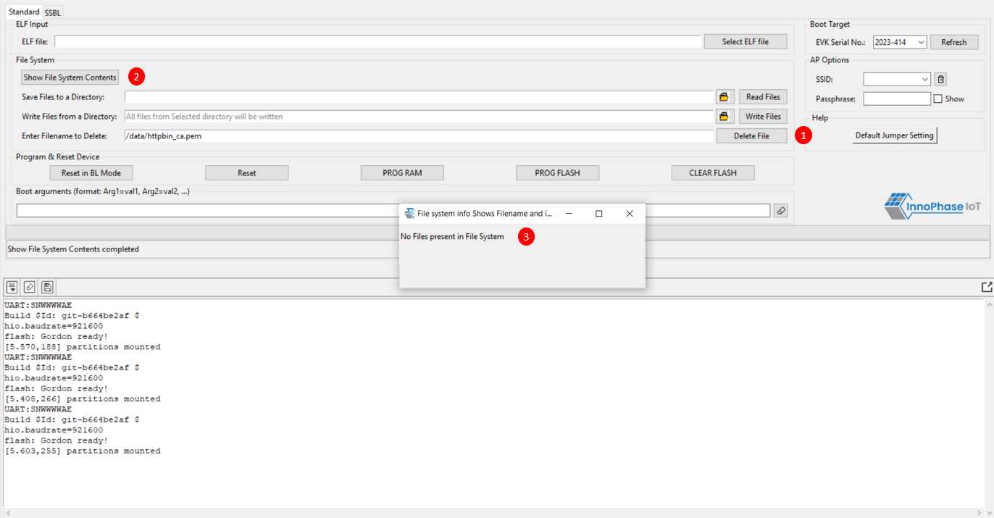

Figure 22: Delete File

**Note**: Clicking on Clear Flash will only clear the application but not the file system contents.